Technical Challenge

Nikiforos Mandilaras - nikmand@outlook.com

Data Ingestion
To begin with, in order to work with Elastic database, we have created an ELK cluster on the cloud, by using Elastic’s corresponding service. Then we used Elasticsearch's python Api in order to ingest the provided documents into the database. At this point we will describe a few aspects of Elasticsearch’s operation, as this will help us to better understand the issues faced, during this challenge.
In Elasticsearch data are stored in indexes, in the form of documents. However, in contrast with relational databases, documents of different structure can be kept in the same index. In fact, Elasticsearch used to assign a type in each document in order to represent the structure of it. Having said that, there is one major difference that distinguishes indexes with “databases” of SQL world. In Elasticsearch all documents that belong in an index, independently of their type, must have the same type for fields with the same name [1].
In this exercise, we were provided with 10 documents, all of different types (some related to others and some not). The issue was that 2 of those, had different types for fields present in other documents as well, such as ‘name’. As a result, they couldn’t be stored in the same index. For those cases, Elasticsearch suggests using one index per document type, but as we had available only one document per type that didn’t seem to be meaningful. Consequently, we ignored those documents.

Chronological order
Apart from the ingestion procedure, we had to present the documents in a chronological order. To achieve that we needed a common time field across documents. Most documents had already a time field, but the name on each one of them was not necessarily the same. Moreover, some documents had multiple time fields. So, in order to address those issues, we preprocessed the documents before the insertion procedure. For each type of document, we picked a time field that best descripted the event and we mapped its value to a newly created, common time field. Then we used the Kibana visualization dashboard in order to present the events chronologically and the results are showed below.
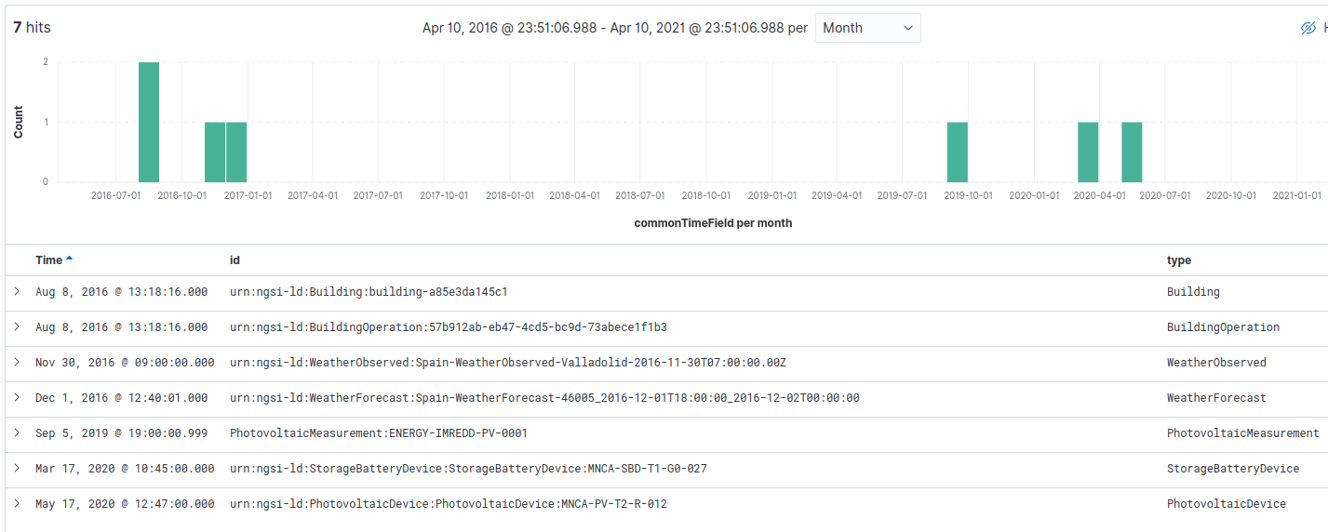Figure 1: Events in Chronological Order
We observe that the events are spanned in the last five years. To better distinguish the different events in time, we annotated them by their type.
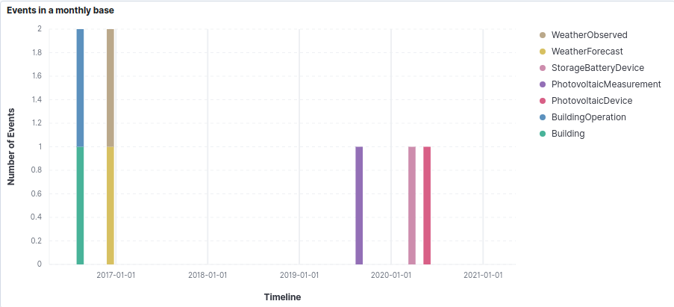Figure 2: Events in Chronological Order along with their type

Weather Data
Concerning the final point of the Tech Challenge, we selected OpenWeather Api [2] in order to bring weather data into our system. The data received, were in json format and contained numerous forecasts in different time frequencies (e.g., minutely, hourly, daily). We chose to work with daily data as those were available for a longer period, specifically for 7 days ahead.
After fetching the data, we performed a transformation in the date field, turning it from Unix time to datetime, in order to be parsed accordingly by Elasticsearch. Then we inserted the data into a new index. We used again the Kibana dashboard for our visualizations.
First of all, we depicted the variation of max and min temperature along the upcoming week (11/4-18/4).
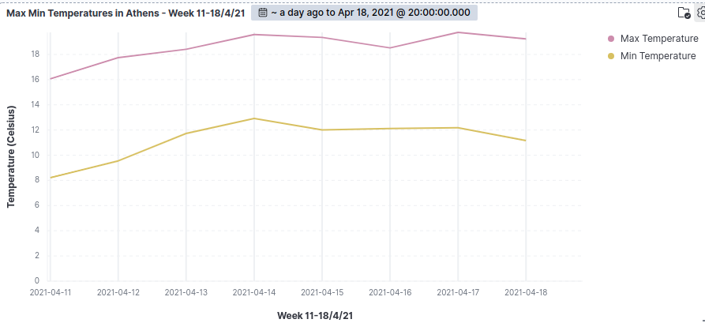Figure 3: Max, Min Temperatures in Athens - Week 11/4 - 18/4
As we can see, there isn’t any major temperature fluctuation and the difference between max and min remains almost the same. Then we continue with a magnitude that concerns individuals, that of temperature feeling.
As it is mentioned in [3], heat index is used in order to determine the actual sense of temperature in humans. This index is depended on actual temperature and relative humidity. Therefore, we depicted those three magnitudes together in one plot, in order to compare if our data comply with the theory.
Although humidity doesn’t have great fluctuations, we can compare the first two days of the week with the last one. In the beginning of the week humidity was between 36-38%, while in Sunday it is going to be around 53%. We can observer that the increase of relative humidity closed, even by a little, the gap between the temperature and the feeling of it. That is something that we expected as the rise of the humidity increases the temperature that humans perceive.
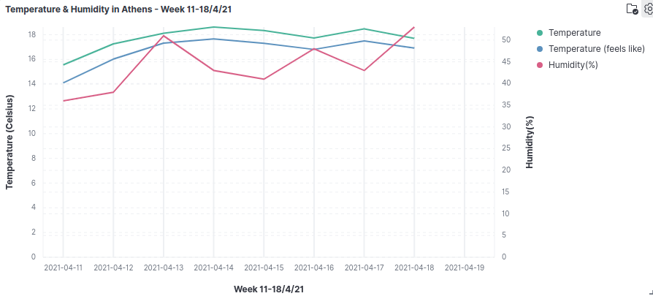Figure 4: Feels like Temperature against actual Temperature and Humidity in Athens - Week 11/4 - 18/4
Finally, we continue with another magnitude that concerns individuals, that of wind speed per day. The maximum speed forecasted is 4.5 meters per second which is quite low.
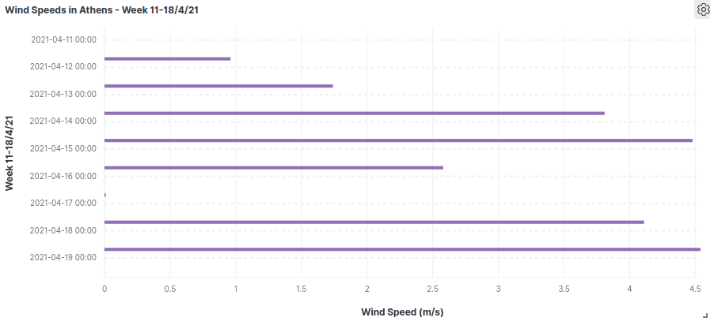Figure 5: Wind Speed in Athens - Week 11/4 - 18/4

References

[1] https://www.elastic.co/guide/en/elasticsearch/reference/current/removal-of-types.html
[2] https://openweathermap.org/api/one-call-api
[3] https://www.weather.gov/ama/heatindex?fbclid=IwAR1ij-6B1OP-jx47GPk0TkSqRl03g4SqI-BYAC11wRcGQwK1jZVM0bOs120

